MA105G.06
1 of 20 Choose the one alternative that best completes the statement or answers the question.
Solve the polynomial inequality and graph the solution set on a number line. Express the solution set in interval notation.
5x² - 3x > 8
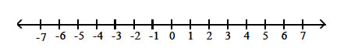
[-1, | 8  5 | ]
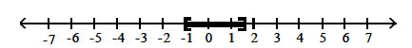
(-∞, -1) ( | 8  5 |  | , ∞)
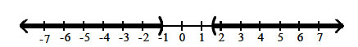
(-1, | 8  5 |  | )
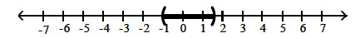
(-∞, -1] [ | 8  5 |  | , ∞)
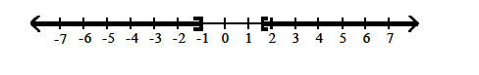
2 of 20
Find the vertical asymptotes, if any, of the graph of the rational function.
f(x) = | x  x² + 4
x = -4, x = 4
x = 4
x = -4
no vertical asymptote

3 of 20
Let R(x) = | x³ - 2x² - 7  x⁶ - 2x⁵ + 6x² - 4 | . How many vertical asymptotes are possible?
3
2
6
5
4 of 20 Find the domain of the rational function.
g(x) = | x + 4  x² + 4
{x|x ≠ -2, x ≠ 2}
{x|x ≠ 0, x ≠ -4}
{x|x ≠ -2, x ≠ 2, x ≠ -4}
all real numbers
5 of 20
Solve the problem.
Is there origin symmetry for the rational function f(x) = | 4x  6x² + 1 | ?
Yes
No

6 of 20
Find the domain of the rational function.
g(x) = | 6x  (x - 1)(x + 7)
{x|x ≠ 1, x ≠ -7}
{x|x ≠ 1, x ≠ -7, x ≠ -6}
{x|x ≠ -1, x ≠ 7}
all real numbers

7 of 20
Solve the problem.
Is there y-axis symmetry for the rational function f(x) = | -4x²  6x⁴ - 3 | ?
Yes
No

8 of 20
Find the horizontal asymptote, if any, of the graph of the rational function.
g(x) = | 6x²  2x² + 1
y = 3
y = | 1  3
y = 0
no horizontal asymptote

9 of 20
If R(x) is a rational function, then R(x) < 0 describes what?
The values of x that make R(x) positive in value
The values of R(x) that make x negative in value
The values of x that make R(x) negative in value
The negative values of x that make R(x) also negative

10 of 20
What is the equation of the slant asymptote for R(x) = | x² - x + 17  x² + 1 | ?
R(x) = x - 1
R(x) = 1
R(x) = x + 17
There is no slant asymptote

11 of 20
Find the indicated intercept(s) of the graph of the function.
x-intercepts of f(x) = | x - 4  x² + 8x - 2
(2, 0)
(8, 0)
(4, 0)
none

12 of 20
Write an equation that expresses the relationship. Use k as the constant of variation.
d varies directly as the square of y.
d |  | = |  | k^/¯y
d |  | = |  | k  ^/¯y
d = ky²
d |  | = |  | k  y²

13 of 20 Solve the problem.
y varies jointly as a and b and inversely as the square root of c. y = 48 when a = 4, b = 8, and c = 36. Find y when a = 2, b = 7, and c = 16.
7.875
31.5
3.5
504

14 of 20
Find the horizontal asymptote, if any, of the graph of the rational function.
h(x) = | 6x³  3x² + 1
y = | 1  2
y = 2
y = 0
no horizontal asymptote

15 of 20
Find the horizontal asymptote, if any, of the graph of the rational function.
f(x) = | 8x  2x² + 1
y = | 1  4
y = 0
y = 4
no horizontal asymptote

16 of 20
Find the indicated intercept(s) of the graph of the function.
y-intercept of f(x) | x² - 6x  x² + 10x - 15
(0, | 2  5 |  | )
(0, 0)
(0, 6)
(0, - | 5  2 |  | )

17 of 20
Find the vertical asymptotes, if any, of the graph of the rational function.
f(x) = | x  x(x- 2)
x = 0 and x = -2
x = 0 and x = 2
x = 2
no vertical asymptote

18 of 20
Solve the rational inequality and graph the solution set on a real number line. Express the solution set in interval notation.
 | x - 9  x + 1 | > 0
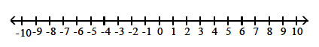
(-∞, -1)
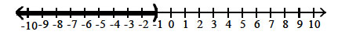
(9, ∞)
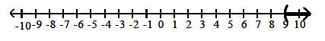
(-∞, -1) or (9, ∞)
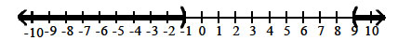
(-1, 9)
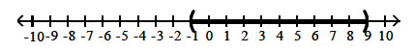

19 of 20

Let R(x) = | x³ - 2x² - 7  x² + 1 | . What kind(s) of asymptotes does R(x) possess?
A single horizontal asymptote
A slant asymptote and a horizontal asymptote
A single slant asymptote
R(x) has no asymptotes

20 of 20
Use the graph of the rational function shown to complete the statement.
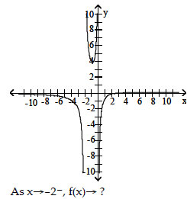
0
-∞
+∞
2

